Automated Multi Crop Irrigation Using IoT

Addagalla Dhanya Sree-19BEC7100

**Abstract**

Multi-crop water system is a fundamental part of present-day horticulture that assists increment with editing yield and ration water assets. The utilization of Web of Things (IoT) innovation in agribusiness has upset conventional water system techniques. In this undertaking, we propose a multi-crop water system framework that uses soil dampness sensors, mugginess sensors, temperature sensors, and an Arduino microcontroller to mechanize the water system process.

            The framework gathers information from the sensors and cycles it utilizing the Arduino microcontroller. The information is dissected to decide the dampness level, stickiness, and temperature of the dirt. In light of this information, the water system framework is controlled to convey the ideal measure of water to the harvests. The framework is associated with an IoT stage by means of a WIFI module which permits ranchers to remotely screen and control the water system framework.

            The proposed framework is supposed to increment crop yield by giving ideal water levels and lessening water wastage. The utilization of IoT innovation makes the framework practical, productive, and harmless to the ecosystem. The consequences of this task can possibly fundamentally affect current agribusiness by further developing harvest yields, decreasing water utilization, and advancing reasonable cultivating rehearses.

Likewise, we will see what and which sort of sensors can be utilized progressively on the off chance that we utilize this approach. Comparison of sensors, voltage utilization and their effectiveness are additionally portrayed.

**Keywords-**Arduino, NodeMCU, IOT, Soil moisture

# Introduction

Horticulture is finished for a huge scope in a considerable lot of the nations. Populace is developing consistently, consequently cultivating is important to create more food. Cultivating incorporates planting, manuring, water system, weeding and collecting out of which water system and manuring are the main ones which need a great deal of consideration. We really want to diminish how much work that ranchers should do and help the harvest's effectiveness using current innovations, like mechanization. We are combining current innovations, for example, robotizing processes, with agribusiness. In this way, to diminish the time spent on the water system and to yield great harvests by not excessively flooding, we are utilizing Soil dampness sensors. Additionally, factors like temperature and mugginess influence the development of harvests. High temperature causes shoot and root development hindrances and high mugginess causes diminished CO2 consumption and decreased happening. To stay away from these issues, we really want to constantly screen them with the goal that ranchers can make essential moves. Thus, here we are likewise utilizing temperature and stickiness sensors. We are redirecting the water to the harvest as indicated by the dampness values recorded. The situation with the siphon and upsides of stickiness and temperature sensors can be observed by ranchers on a page.

A DC shunt motor is a self-excited DC motor with field windings that are shunted to or linked in parallel with the motor’s armature winding.You can easily control the Speed of a Shunt motor. Despite the load changes, Shunt motors can maintain their constant speed. As the load increases the armature

# Methodology

The multi crop water system framework created in this study comprises of soil moisture sensors, humidity and temperature sensors, DC pumps, Arduino and NodeMCU. The soil moisture sensors are utilized to quantify the dirt dampness content, while the stickiness and temperature sensors are utilized to screen the developing circumstances.

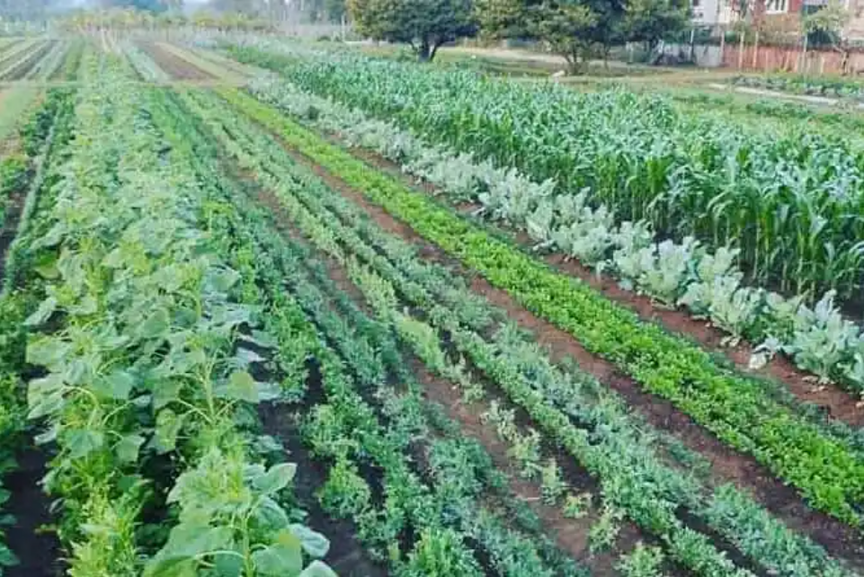

Fig.1 Multi crop

The multi crop water system framework created in this study comprises of soil moisture sensors, humidity and temperature sensors, DC pumps, Arduino and NodeMCU. The soil moisture sensors are utilized to quantify the dirt dampness content, while the stickiness and temperature sensors are utilized to screen the developing circumstances.

The DC pumps are utilized to water the yields, while the Arduino and NodeMCU sheets are utilized to control the framework's activity. The transfers are utilized to switch the DC siphons on and off. The framework works as follows: The soil moisture sensors constantly screen the dirt dampness content. On the off chance that the dampness content falls under a specific limit, the Arduino board conveys a message to the NodeMCU board to initiate the DC pumps. The pumps then water the harvests until the dampness content arrives at the ideal level.

The mugginess and temperature sensors screen the developing circumstances and change the water system plan in like manner. The whole framework can be checked.

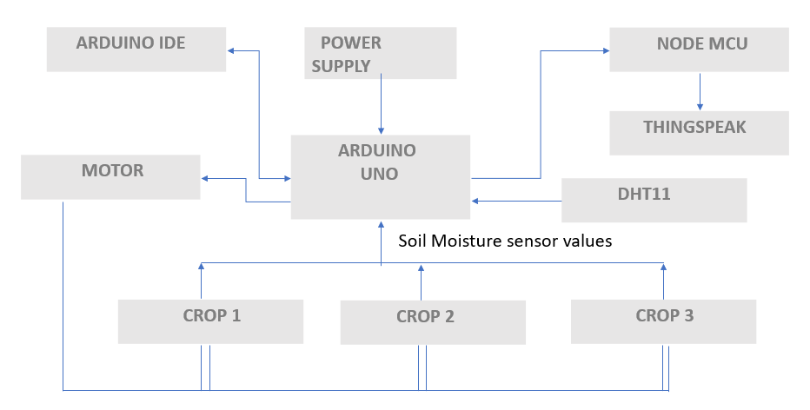

Fig.2.Block diagram of the irrigation system

Soil moisture sensor

Sensor used is resistive soil moisture sensor. Resistive soil dampness sensors are generally involved sensors in agribusiness to quantify the dampness content of the soil. These sensors work in view of the guideline of electrical conductivity in the dirt.

They comprise of two cathodes that are embedded into the dirt, and the obstruction between these terminal’s changes with the dampness level. As the dirt dampness builds, the conductivity of the dirt increments, bringing about a diminishing in the sensor's resistance. The opposition values are then connected with dampness levels utilizing adjustment bends or conditions.

Resistive soil dampness sensors are savvy and moderately easy to utilize and install. They are viable with different microcontrollers and Arduino loads up for information procurement and analysis. These sensors are flexible and can be utilized for an extensive variety of soil types and crops. They give constant estimations, empowering ranchers to screen soil dampness levels and pursue informed water system choices.

**Volumetric Water Content**

The volumetric water content is the extent of water volume to soil volume. Expecting a unit surface region, volumetric water content can be expressed as a proportion, rate, or profundity of water per profundity of soil, for example, crawls of water per foot of soil.

Analog Output = (ADC Value)/1023

               Moisture in percentage = 100 - (Analog output * 100)

For zero moisture, we get a maximum value of 10-bit ADC, i.e., 1023. This, in turn, gives 0% moisture.

**Result**

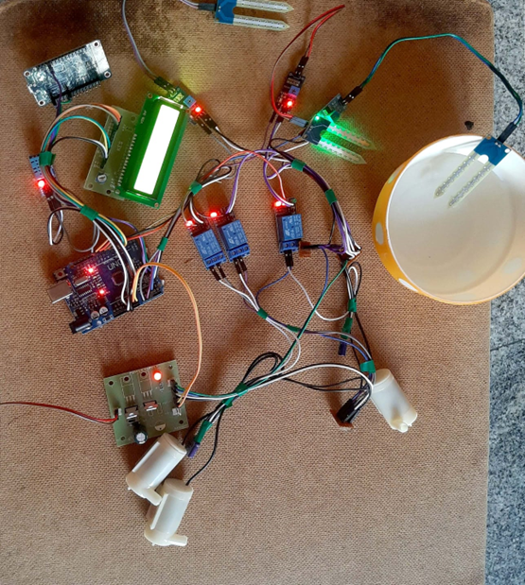

Fig.3. Automated irrigation system

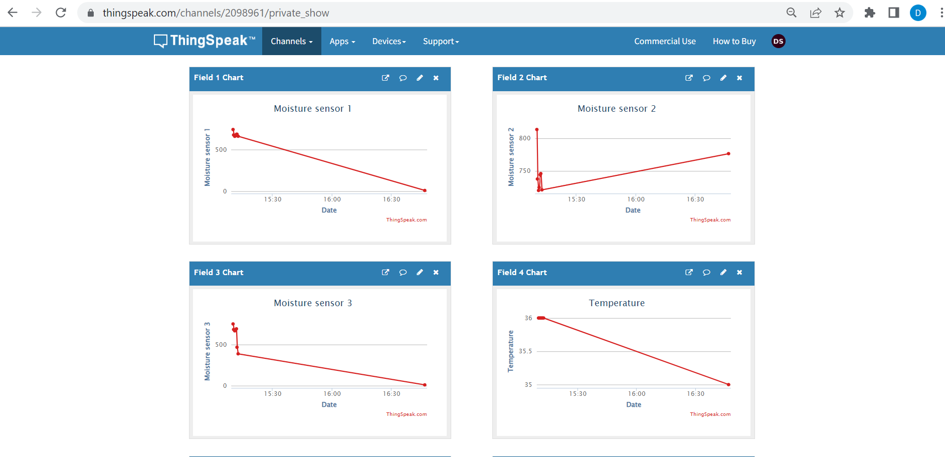

Fig.4. Sensor Readings

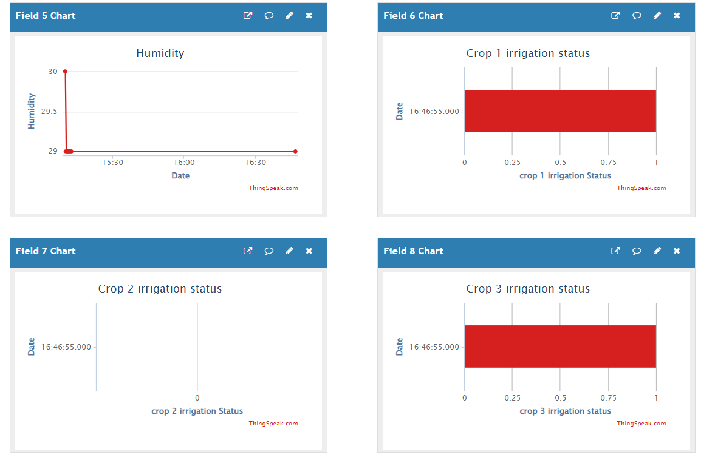

Fig.5. Crop irrigation status

# Real time usage

Due to their limited coverage, resistive moisture sensors are not practical.

Due to the length of their probes, sensors including amplitude domain reflectometry, gypsum blocks, time domain reflectometry, frequency domain reflectometry, and others are employed.

The sensors' voltage and accuracy levels are as follows:

TDR Sensor: TDR sensors are typically used to measure the amount of moisture in soil. They operate by firing electromagnetic pulses into the ground and timing how long it takes for the pulses to reflect back. TDR sensors typically require voltage levels between 5 to 24 volts, with 12 volts being a typical voltage level. Under ideal conditions, TDR sensors can achieve an accuracy of about 2-3% volumetric water content (VWC) when properly calibrated. However, it's important to be aware that the accuracy may change depending on the soil type, saltiness levels, and sensor adjustment.

FDR Sensor (Frequency Domain Reflectometry): FDR sensors are also used to determine the amount of soil moisture. They operate by analysing the dirt-water framework's recurrent response. Typically, a power supply voltage ranging from 12 volts to 24 volts is used for FDR sensors. Similar to TDR sensors, if FDR sensors are well aligned and used in the right soil conditions, their precision can range from 2-3% VWC. Nevertheless, variations can occur in light of specific factors and calibration approaches, just like with any sensor.

Gypsum Sensor: Gypsum sensors, also known as gypsum blocks, are widely used to measure the amount of soil moisture. These sensors are made of gypsum with cathodes implanted. Gypsum sensors typically require voltages between 1.5 and 9 volts, with 3 volts serving as a typical voltage level. Under optimal conditions, the VWC of gypsum blocks can range from 3-5%. However, factors such as temperature, soil salinity, and other factors may have an impact on gypsum blocks, leading to some degree of calculation error.

In accordance with the neutron balancing rule, neutron probes are used to estimate soil wetness. These tests frequently use a small radioactive source to deliver fast neutrons into the soil and detect the slow neutrons produced by interaction with soil moisture. Depending on the specific test model, neutron tests typically require a high-voltage power source in the range of a few hundred volts to a few kilovolts.

|  |  |  |  |
| --- | --- | --- | --- |
| Sensor | Method | Advantages |  |
| Gypsum Blocks | Two electrodes inside the porous material such as gypsum measures the resistance itself  -The water from the soil moves into the gypsum decreases the resistance and water pulled from the gypsum increases the resistance  -Low resistance means higher moisture level and vice versa | -Minimal expense  - precise in mud soil  - simple to work  - low power utilization | - duration is around 1 to 2 years  -  low accuracy in Sandy soils  - less repeatability |
| Electrical Conductivity Probes | -Measure the current of electricity between two probes (direct contact with soil)  -More moisture has better the conductivity and vice versa | -  high accuracy in clay soil  - low cost | - very sensitive to the spacing of the groups and soil type  - less repeatability |
| Dielectric:  Capacitance | -Two electrodes of dielectric have direct contact with soil and high oscillating frequency is applied to the electrodes and measures resonant frequency  -The resonant frequency vary by moisture level of soil  -Large change in frequency have higher moisture level and vice versa | -  high accuracy  - good for research use  -  read soil volumetric water content directly  - low maintenance | - expensive  - not practical for controlling irrigation system |
| Dielectric: TDR | -Measurement of time travel along the length of the probe rod by electromagnetic pulse  -More travel time in higher moisture level and vice versa | -  high accuracy  - good for research use  -  read soil volumetric water content directly  - low maintenance | - expensive  - not practical for controlling irrigation system  -Very complex |

# Conclusion

The IoT innovation's capacity to increase the productivity and viability of water system frameworks is demonstrated by the multi-crop water system framework developed in this study. The system's ability to regulate moisture levels and maintain appropriate growing conditions for various harvests might result in significant increases in crop output and water usage. Based on the readings from the soil dampness sensor, we could direct the water to various yields. Ranchers might also use the Wi-Fi module to remotely monitor the issue with their water system.

Finally, we might draw the conclusion that automating the water system with IoT innovation will make it simpler. In this framework, we used Nodemcu, which can transmit sensor readings over distances greater than 500 metres.

Thus, by putting the suggested plan into practise, we may help ranchers save time and use less water. Additionally, it reduces the need for labour while increasing productivity in yield development.

Due to their smaller inclusion area, resistive dampness sensors are practically useless. As a result, real-time usage sensors are also recorded and compared. Additionally shown are the ongoing sensors' voltage usage and precision.

**Future Work**

The framework can be expanded for usage in larger horticultural settings using the sensor data provided and further creative work, leading to a more viable and beneficial farming economy.

# References

[1]. J.Karpagam, I. Infranta Merlin, P.Bavithra, J.Kousalya-Smart Irrigation System Using IoT published by ieee in 2020. https: //ieeexplore.ieee. org/document /90742 01

[2]. Bhanu K.N, Mahadevaswamy H.S, JasmineH.J-iot based smart system for enhanced 1rr1gation m agriculture published by IEEE in 2020. https://ieeexplore.ieee.org/document/91560 26

[3]. Shyam Pereka, Reddy Sudheer, Allu Ravi Teja, Esai Naveen Kumar-smart irrigation based on crops using iot published by ieee 2020. https://ieeexplore.ieee.org/document /93427 36

[4]. Remote Sensing and Control of an Irrigation System Using a Distributed Wireless Sensor Network by Yunseop (James) Kim, Member, IEEE, Robert G. Evans, and William M. Iversen, IEEE Transaction on Instrumentation and Measurement, VOL.5.7.

[5]. Sumeet. S. Bedekar, Monoj. A. Mechkul, and Sonali. R. Deshpande "IoT based Automated Irrigation System", IJSRD - International Journal for Scientific Research & Development.

[6]. Indu Gautam and S.R.N Reddy, "Innovative GSM based Remote Controlled Embedded System for Irrigation", International Journal of Computer Applications Vol. 47 -No.1